Giant intra-abdominal desmoid Type Fibromatosis in a Young Male: A Case Report

Rauf Ahmad Wani, Gowhar Aziz Bhat, Zamir A Shah, Rayees A Dar, Asif Mehraj
Department of General and Minimal Invasive Surgery, SKIMS

Correspondence:
Dr. Rauf Ahmad Wani, MS
Professor, Colorectal Surgery, SKIMS
Email: rauf.wani@skims.ac.in

ABSTRACT

Desmoid tumors are rare neoplasms that occur in the extremities, the trunk and the abdominal cavity. We present a case of 40 year-old male who presented with swelling of abdomen and abdominal pain. He was presented to our hospital with no history of surgery, trauma or familial adenomatous polyposis. Computed tomography revealed a large tumor in the abdominal cavity ans surgical resection was performed. The tumor developed from the ileocolic mesentery and was 16× 14× 16 cm in size. Tumor revealed fascicles of spindle cells with intervening collagen and was positive for SMA, Vimentin on IHC and impression of inta abdominal Desmoid –type Fibromatosis was made. In this case surgery was the optimal treatment according to the symptoms and there are no signs of recurrence till last follow up. Desmoid tumors are invasive in nature and local recurrence is common, so sufficient resection including normal tissue and strict follow-up are necessary.

BACKGROUND

Desmoid-type fibromatosis (DTF) is a tumor that develops as a result of neoplastic proliferation of myofibroblasts within the musculoaponeurotic stroma. They overall compose 0.03% of all tumors and <3% of soft tissue neoplasms (1). These tumors commonly affect young adults in the age group of 25–35 years and have a female-to-male ratio of 2:1 (2). DTF can involve any part of the body , but they most freuently arise from the abdominal wall or extremities and the abdominal organ or mesentery is rarely involved (3). DTFs can be hereditary or sporadic. Heriditary form can be associated with familial adenomatous polyposis (FAP) or Gardner’s syndrome. Patients having desmoid tumors carry an increased risk for FAP, indicating the need for screening (4). General population incidence of DFT is 2–4 cases per million, and incidence amoung FAP patinsts is nearly 3% (5, 6).

CASE DESCRIPTION

A 40 year old male with no comorbidity was transferred from a rural hospital for a more extensive workup. The patient’s primary concerns included a 3 months history of abdominal pain with swelling right lower abdomen without any history of nausea, vomiting, constipation, diarrhea, or any other associated symptoms. The patient was otherwise healthy without any previous surgical or medical interventions with no significant family history. On examination, the patient had right side abdominal swelling crossing midline which was firm but non-tender and was crossing midline
Computer tomography (CT) of the chest, abdomen and pelvis was done outside our hospital, demonstrated a large intra-abdominal mass measuring up to 18 cm causing displacement of gut to left side of abdomen and was abutting ascending colon. Trucut biopsy of the mass was performed under ultrasound guidance outside our hospital which was in favour of myofibroblastoma or fibroma.
Upper gastrointestinal endoscopy was normal and colonoscopy revealed compressed ascending colon secondary to external compression, with rest of colon being normal. CEA and CA 19-9 levels were normal along with normal hematological and biochemical investigation and Covid 19 RTPCR was negative.

After appropriate counseling, the patient was taken for open surgical tumor resection. After laparotomy incision, the tumor was readily appreciable and appeared well-defined and encapsulated. Adhesions were carefully released and the tumor was found to be adherent terminal ileum, cecum, and ascending colon with loss of tissue planes with them. The en bloc resection of the tumor along with the terminal ileum, cecum and ascending colon with primary ileocolic anastomosis. The patient tolerated the surgery well and had an uneventful postoperative period and was discharged home by day 6.

Gross examination of the specimen revealed 16× 14× 16 cm mass adherent to ascending colon and terminal ileum and lied in pericolic fat. Microscopic examination of tumor revealed fascicles of spindle cells with intervening collagen. All surgical margins were negative. On immunohistochemistry tumor (IHC) was positive for SMA, Vimentin and negative for Beta-catenin, h-Caldesmon, CD34, CD117, S-100, EMA with Ki-67 of 15% and impression of Desmoid –type Fibromatosis was made. Patient is under regular follow up for the last 18 months and is doing well.

DISCUSSION

DTF are uncommon stromal tumor that can develop sporadically or in association with hereditary syndromes. They can arise from from any part of the body and are generally classified into three main anatomic locations: extra-abdominal (trunk and extremities), along the abdominal wall and least commonly, intra-abdominally. The most likely location for intra-abdominal desmoid tumors (DTs) is the mesentery, especially the small bowel [7]. Intraabdominal DTs can present with symptoms of intestinal obstruction, bowel ischemia, and abdominal distention [8]. In this case report, we describe a 40-year-old male with a large sporadic desmoid tumor arising from the ileocolic mesentery presenting with abdominal pain and abdominal mass. Our case is a rarity in view of DT being intra-abdominal, and the patient having no specific medical history.
Imaging studies, like CT and MRI, are used for preoperative assessments and for planning of resection, and are also used for detecting recurrence and to monitor tumor response to radiotherapy or medical therapy for unresectable or recurrent tumors (9). Intra-abdominal DTs may appear to be mostly well-circumscribed on CT and MRI, they are often infiltrative and ultrasound characteristics of intra-abdominal DTs are often non-specific (10).

Our ability to understand and investigate DTF prognosis recurrence and treatment efficacy is limited due to the rare occurrence, varied anatomical presentation and variable presentations of DTF. Consensus treatment algorithm determined by the European Organization for Research and Treatment of Cancer (EORTC), Soft Tissue and Bone Sarcoma Group (STBSG), and Sarcoma Patients EuroNet (SPAEN) was proposed in 2015 acknowledged that there may be spontaneous regression of tumors at anatmical sites of DTS roposed but surgery remains the main treatment for progressive and operable intra-abdominal tumors (11). The patient had an unusually large symptomatic tumor in addition to worsening abdominal symptoms over 12 weeks, so surgery was indicated. Larger studies have shown higher recurrence rates for the patients with R1 margins in comparison to R0 margins. The other studies have shown that margin status is a predictor of recurrence with univariate analysis but not on multivariate analysis (2).

CONCLUSION

DTF is a benign tumor of myofibroblast origin most commonly arising in the extremities or abdominal wall and we present a rare occurrence in the ileocolic mesentery. Long term in mesenteric DTs remains undetermined given its rarity, different locations along with variable presentation. More conservative approaches and watchful observation is recommended by recent guidelines, but our case emphasized the need for immediate surgical intervention considering symptoms and size of the tumor .

REFERENCES:

- Stürmlin J, Banz V, Metzger J. Diagnosis and management of the intra-abdominal desmoid tumour. J Surg Case Rep. 2012 Feb 1; 2012(2):2. doi: 10.1093/jscr/2012.2.2. PMID: 24960778; PMCID: PMC3649496.
- Howard JH, Pollock RE. Intra-Abdominal and Abdominal Wall Desmoid Fibromatosis. Oncol Ther. 2016;4(1):57-72. doi: 10.1007/s40487-016-0017-z. Epub 2016 Feb 3. PMID: 28261640; PMCID: PMC5315078.
- Ebeling PA, Fun T, Beale K, Cromer R, Kempenich JW. Primary Desmoid Tumor of the Small Bowel: A Case Report and Literature Review. Cureus. 2019 Jun 17;11(6):e4915. doi: 10.7759/cureus.4915. PMID: 31423391; PMCID: PMC6692092.
- Koskenvuo L, Peltomäki P, Renkonen-Sinisalo L, Gylling A, Nieminen TT, Ristimäki A, Lepistö A. Desmoid tumor patients carry an elevated risk of familial adenomatous polyposis. J Surg Oncol. 2016 Feb;113(2):209-12. doi: 10.1002/jso.24117. Epub 2015 Dec 10. PMID: 26663236.
- Skubitz KM. Biology and Treatment of Aggressive Fibromatosis or Desmoid Tumor. Mayo Clin Proc. 2017 Jun;92(6):947-964. doi: 10.1016/j.mayocp.2017.02.012. PMID: 28578783.
- Nieuwenhuis MH, Casparie M, Mathus-Vliegen LM, Dekkers OM, Hogendoorn PC, Vasen HF. A nation-wide study comparing sporadic and familial adenomatous polyposis-related desmoid-type fibromatoses. Int J Cancer. 2011 Jul 1;129(1):256-61. doi: 10.1002/ijc.25664. Epub 2010 Nov 3. PMID: 20830713.
- J. J. Sugrue, S. B. Cohen, R. M. Marshall, and A. I. Riker, “Palliative resection of a giant mesenteric desmoid tumor,” The Ochsner Journal, vol. 15, no. 4, pp. 468–472, 2015.
- C. Escobar, R. Munker, J. O. Thomas, and G. V. Burton, “Update on desmoid tumors,” Annals of Oncology, vol. 23, no. 3, pp. 562–569, 2012.
- Kovačević K, Obad-Kovačević D, Popić-Ramač J. Sporadic giant intra-abdominal desmoid tumor: A radiological case report. Mol Clin Oncol. 2017 Jun;6(6):896-898. doi: 10.3892/mco.2017.1250. Epub 2017 May 8. PMID: 28588785; PMCID: PMC5451873.
- Gari MK, Guraya SY, Hussein AM, Hego MM. Giant mesenteric fibromatosis: Report of a case and review of the literature. World J Gastrointest Surg. 2012 Mar 27;4(3):79-82. doi: 10.4240/wjgs.v4.i3.79. PMID: 22530082; PMCID: PMC3332225
- Kasper B, Baumgarten C, Garcia J, Bonvalot S, Haas R, Haller F, Hohenberger P, Penel N, Messiou C, van der Graaf WT, Gronchi A; Desmoid Working Group. An update on the management of sporadic desmoid-type fibromatosis: a European Consensus Initiative between Sarcoma PAtients EuroNet (SPAEN) and European Organization for Research and Treatment of Cancer (EORTC)/Soft Tissue and Bone Sarcoma Group (STBSG). Ann Oncol. 2017 Oct 1;28(10):2399-2408. doi: 10.1093/annonc/mdx323. PMID: 28961825; PMCID: PMC5834048.
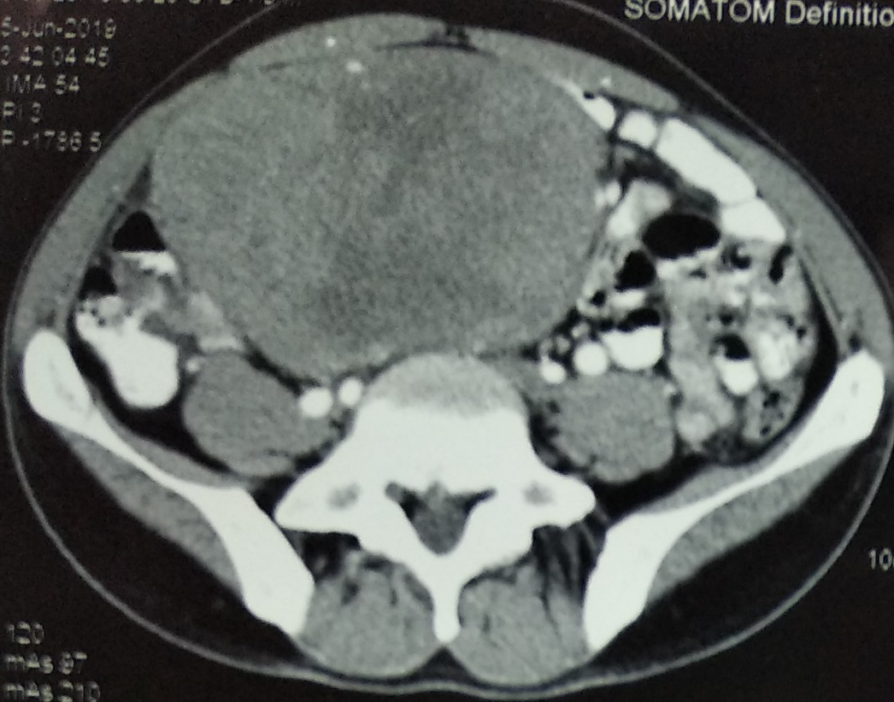
(a)
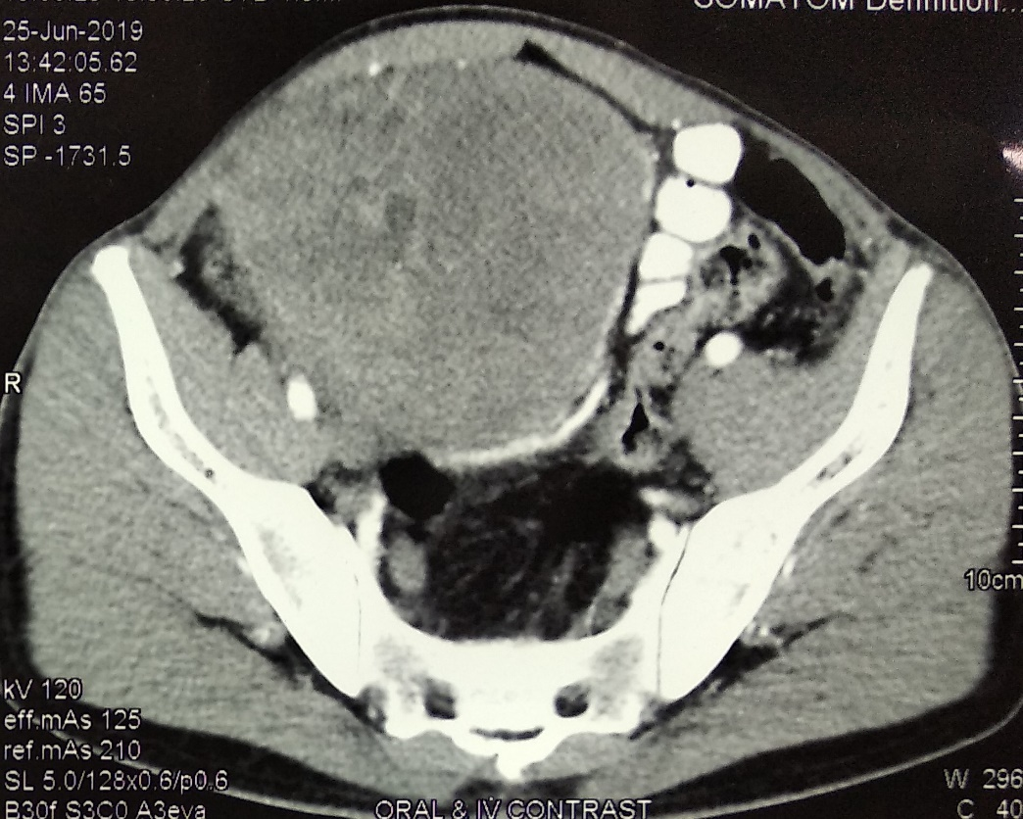
(b)

Figure 1 (a, b): CECT scan showing large intra-abdominal mass displacing large gut to left side.
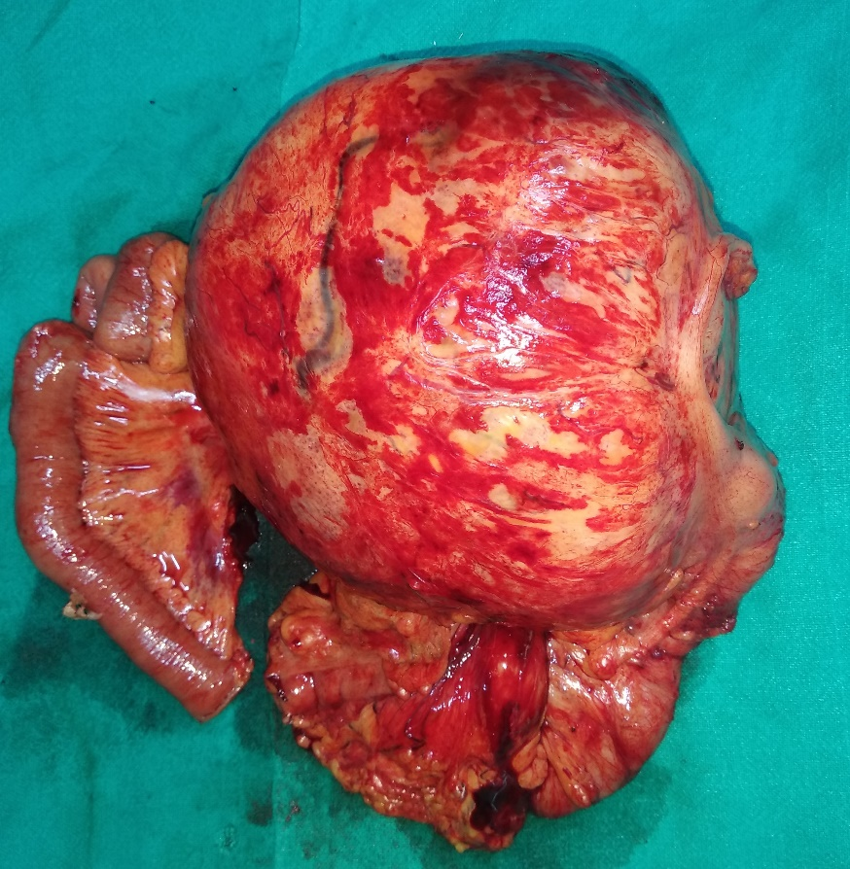
(a)
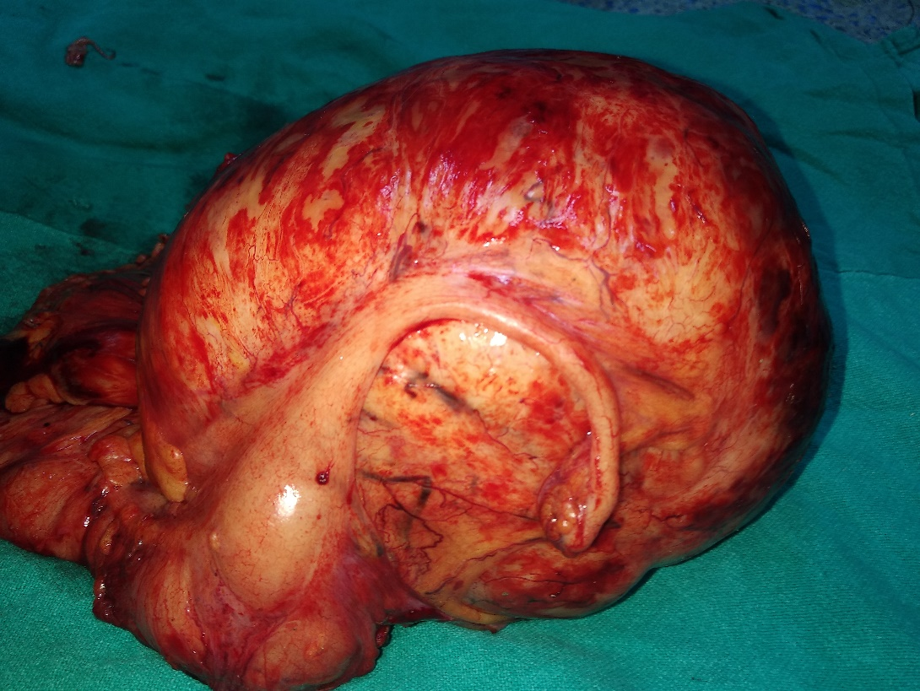
(b)
Figure 2(a, b): Photographs of specimen showing large mass adherent to right colon and terminal ileum.

